# Question 3

**Based on an investigation on your classmates and friends, is operating system an important factor that influence the purchase of smart phone? If yes, why? If not, then what are the important factors that influence the purchase of smart phone?**

As the smart phone is more and more common and indispensable in everyday life, the purchasing of a suitable smart phone is very important. People tend to take a lot of factors into consideration. Among these factors, the operating system of the smart phone, like Android or Apple iOS, is an important factor that influence the choosing of a smart phone. However, it is not the only important factors.

To search for the impact of operating system on people's choice to buy mobile phones, as well as the other important factors that influence the purchase of smart phone. We have an investigation on our classmates, family and friends. We investigated the factors affecting people's purchase of mobile phones in the form of questionnaire. The people who filled in the questionnaire included college students, postgraduates and social personnel. The specific contents and statistical results of the questionnaire are listed as follows.

**the factors that influence the purchase of smart phone**

**Q1.** As for you, do you think operating system (like Android, Apple iOS) is an important factor that influence the purchase of smart phone?

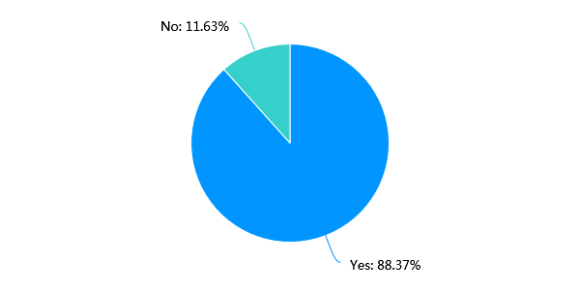

**Q2.** Which operating system would you like to choose when you buy the smart phone?

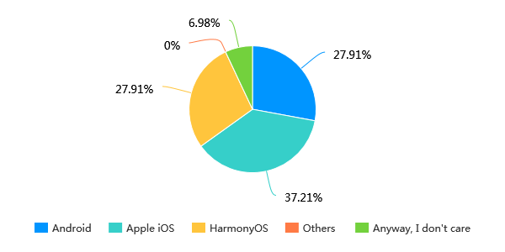

**Q3.** Can you accept buying a mobile phone with an operating system that is not your ideal?

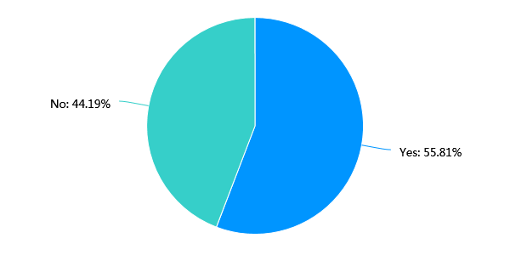

**Q4.** Choose the first three factors that you would consider when buying a mobile phone.

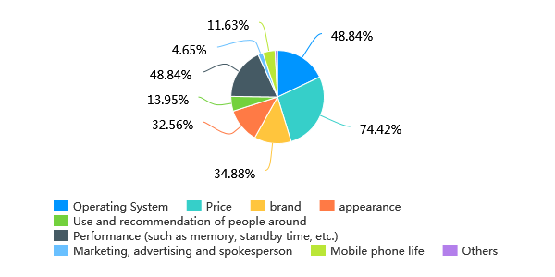

According to the questionnaire, nearly 90% of people recognize the importance of operating system for mobile phone purchase. Furthermore, when buying smart phone, people may choose Apple iOS, Android or HarmonyOS, but only 6.98% of people don’t care which operating system the smart phone is used. Nearly half of the respondents indicated that they could not accept the purchase and use of mobile phones without the operating system they wanted. All these statistics show the importance of the operating system when buying smart phones. But on the other hand, when people buy smart phones, they will also consider some other important factors in addition to the operating system. According to our search, the top three influence factors of buying smart phone are price, operation system and performance (like memory, standby time, etc.). Other factors such as brand, appearance and surrounding people recommends are also influence factors.

Now I’ll first analysis the importance of operating system of a smart phone. When buying a mobile phone, it is undoubtedly very important to choose an appropriate operating system, since the operating system is closely related to the daily usage and application of the mobile phone, which directly affects the sense of experience of mobile phone operation.

Firstly, different operating systems will bring performance gaps and different user experiences. A good operating system will lead to faster speed, fewer jams and better information security, which will bring users a good user experience and are also some of the main selling points of mobile phones. Besides, different operating systems have different modes of operation and shortcuts, which makes users need to adapt and learn again after adapting to one operating system and then transferring to another operating system. That also brings a certain transfer cost.

Secondly, a very important difference between different operating systems is that they mean different ecosystems. The software and configuration of different operating systems are not exactly the same, and often cannot be shared. So, choosing an operating system with more people usage and wider ecology will bring convenience to users' subsequent use. At the same time, the quality and security of the applications is also different for different operating system. For instance, Android's open-source feature has brought a lot of application injection and a more and more sound ecology. However, at the same time, the uneven quality of app is also one of the points that Android has been criticized. On the contrary, the Apple iOS is a closed system with a uniformly managed application store. Thus, the quality of the application is generally high, especially there will not be too many pop-up ads, mobile phone viruses, etc. but at the same time, since it is a closed system, Apple users, including individual users and manufacturer users, have very limited configurability and scalability of the apple system.

Thirdly, with the development trend of smart phones, the importance of operating system will increase. The full screen smart phone makes the screen more important, which also leads to a weaker sense of the existence of hardware, and the space that industrial design can display will be smaller and smaller. In this general trend, the content presented on the screen, that is, the importance of mobile OS itself, will become stronger and stronger. In other words, the features of a product need to be displayed through the OS.

In addition to the operating system, there are other factors that have an important impact on the choice of smart phones. Price is one of the most important factors. Smart phones with different prices face different user groups. The smart phone performance is also important. Users will consider the memory and storage capacity, the performance of the battery, the reaction speed, safety and so on. While some of these performances is related to the operating system of the smart phone, it also has to do with the hardware and other factors. Besides, the brand, the appearance and other people’s recommendation are also important factors that will contributes to the purchase of smart phone.